**

**College of Business Administration**

**Management and Marketing Department**

Course Syllabus

MGT 205 – Organization Behavior

Dr. Abrar Abul (Ebel)

# Lecture Time and Location

**MGT205/04A**:Mon Wed, 9:30 AM –10:45 AM, CG 1016

**MGT205/03A**:Mon Wed, 2:00 PM –3:15 PM, CG 1016

# Contact Information

**Location** :Management and Marketing Department – 1st Floor

**Email**: abrar.ebel@ku.edu.kw

**Office Hours**: Mon Wed, 1:00 PM – 2:00 PM or by email appointment

**Course Description**

The intent of this course is to study the human behavior in organization including the analysis of individual, group, and inter-group relations within a broad range of organizational settings. The study of the course may include concepts, theories, and models related to the topics of the course. Consideration should be given to the environmental, international, ethical, and technological dimensions of issues related to the course subject matters.

**Course Prerequisite:** MGMT 201: Principles of Management

**Course Learning Objectives (CLOs)**

The learning outcomes for this course, listed below, relate to the learning goals of the College of Business Administration Undergraduate Program, which can be found in the appendix at the end of this syllabus. The numbers in parenthesis indicate to which specific learning goal the outcome relates.  
Upon successful completion of the course, students will be able to:

1. Understand individual behavior in organizations, including diversity, attitudes, job satisfaction, emotions, moods, personality, values, perception, decision making, and motivational theories.
2. Analyze and address situations in which organizational behavior issues exist, providing potential practical solutions to such issues. (LG. 1, LG. 5)
3. Understand group behavior in organizations, including communication, leadership, power and politics, conflict, and negotiations. (LG. 1, LG. 4)
4. Experience in analyzing and critically discussing organizational behavior and business cases and ethical dilemmas. (LG. 1, LG. 4)
5. Understand the organizational system, including organizational structures, culture, human resources, and change.

**My Expectations of You**

The focus of the course will be applying concepts and ideas to real-world examples, primarily through our case discussions. I intend to keep lecturing to a bare minimum. For the class to work well, and for you to benefit from it, preparation for each class meeting is essential: All students are expected to arrive at class having read the assigned chapter and case and prepared to offer and defend their recommendations. All students are expected to arrive on time and leave on time. No phones or tablets or other electronics are to be used in class for personal or entertainment reasons.

**Required Material  
Textbook**:  
Stephen Robbins & Timothy Judge, Organizational Behavior, 18th Pearson, 2019.

**Additional Material:**

* Other material is available on Teams **E-Learning System:** Teams
* An intention to learn and a positive growth mindset.
* Notebook and Pen

**Course Requirements and Policies**

● **Class discussion** will be assessed based on your contributions to class discussion and listening. Of course, the underlying condition for class participation is attendance. I expect you to attend all sessions. Prior to class, you should thoroughly read and prepare the case for that day, including answering the study questions. Please ensure that you have used the frameworks, tools, and ideas from the readings in your analysis as appropriate. In grading class participation, I look at both the quantity and quality of contribution. With regards to quality, some of the criteria I shall apply include:

**● Are** the points made relevant to the discussion?

**● Do** they go beyond a mere recitation of case facts, and are implications clearly drawn?

**● Is** there evidence of analysis rather than expressions of opinions?

**● Are** the comments linked to those of others?

**● Did** the contribution further the class’s understanding of the issues?

**● Is** the participant a good listener?

**● Do** comments raise interesting questions?

**● In** discussion, do the comments fit in the class context?

**● Does** the analysis make use of models and techniques from the readings or lectures?

**● Are** comments made in a respectful, professional, and constructive manner?

Students should not expect to receive full points for participation. Simply being present does not warrant full credit, nor does frequent participation that does not advance the learning of the class. I will use “cold calling” occasionally, so you need to be prepared for each class. Cell phones must be turned off or set to the “silent” mode during classes. Laptops may not be used during case discussion segments and activities.

● **Exams:** We will have **THREE** examinations, two midterms and a final exam, which will cover the course material to that point in the course, including lectures, discussions, and readings. Details about exam contents, time, and location will be discussed in the class. Missed examinations may not be made up without prior permissions, no exceptions.

● **Case Discussion presentation, Assignments and Quizzes:** During the course each student will have the responsibility to read a chapter and a case study ahead of time and prepare a presentation for the class. That is, each student will have to lead the discussion in class in regard to their assigned chapters and/or readings. In addition, students are encouraged to research material from other sources about the topic; note it is important to cite (reference) your sources. All students will have to present/lead the discussion at least once during the course. The details will be discussed later in class.

All students should be prepared for the case and have read the case, they will be quizzed on the case one lecture before the case study lecture.

Further, there will be quizzes on other class material, discussed further in class.

And there will be various assignments throughout the semester. The assignments will help you understand the material and tie the concepts.

**● Final Project:**

By the end of the semester students in teams of 1 to 3 (no more than 3) will present about a well-known company or leader explaining their leadership, HRM, and organizational practices and their employees’ thoughts and attitudes. The final project is worth 15% of the final grade.

**The focus of the final presentation is to examine the company’s Organizational culture and Organizational behavior practices.**

**● The presentation must have an introduction, body, and conclusion. It must have headings and subheadings.**

**● Font is Times New Roman, font size12.**

**● In-text citations and references must be used (based on English 126), Follow APA style.**

**● Presentations due date will be discussed further in class.**

* **Attendance and Participation:**

Every student in this course must abide by the Kuwait University Policy on Attendance (published in the Student Guide, Chapter 3, Section 13). A copy of the student guide can be accessed online on:

http://www.kuniv.edu/cs/groups/ku/documents/ku_content/kuw055940.pdf

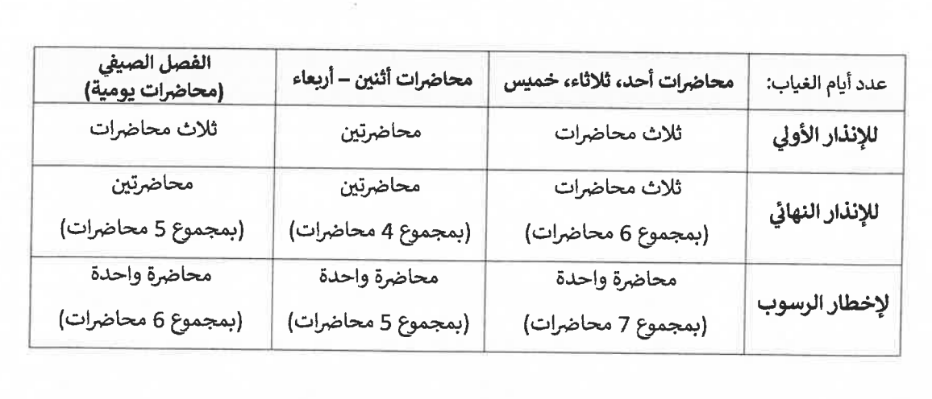

This course has a significant seminar component and class participation is critical to the learning experience. Participation will be assessed in each class period. Your class participation and attendance will both contribute to your score of in-class performance.

* **Cheating and Plagiarism:**

Every student in this course must abide by the Kuwait University Policy on Cheating and Plagiarism (published in the Student Guide, Chapter 3, Section 2). A copy of the student guide can be accessed online on:

<http://www.kuniv.edu/cs/groups/ku/documents/ku_content/kuw055940.pdf>

https://cgs.ku.edu.kw/traditional-thesis/citation-and-plagiarism/

**This policy is to be applied for all work submitted or presented.**

Please carefully note all sources and assistance when you turn in your work. Under no circumstances should you take credit for work that is not yours. You should neither receive nor give any unauthorized assistance on any deliverable. **If you have any questions about what constitutes “unauthorized assistance” please email me before the deliverable is submitted**.

**Copy and pasting from AI is considered cheating. AI use and not correctly noting the use and help of AI is considered cheating.**

All assignments, projects, essays, presentations are to be your work only and not done or taken by an AI or another person (relative or paid for services).

Paraphrasing without correctly citing the source is plagiarism and not permitted.

Students must refer to MLA or APA writing style for their assignments and report writing and presentations. Refer to the English Language Center for help.

● **Writing Style:** Students must refer to MLA or APA writing style for their assignments and report writing. Refer to the English Language Center for help.

**Grading**

The scores in this course will be the weighted average of the following items:

page3image19301696

|  |  |
| --- | --- |
| **Weight** | **Description** |
| 2% | **Class Discussion** |
| 23% | **Case assignments/presentations** |
| 30% | **Midterms** |
| 30% | **Final** |
| 15% | **Final Presentation** |
| 100% | **Total** |

**Grade Distribution**

|  |  |
| --- | --- |
| **Grade** | **Range** |
| A | 95.00 - 100.00 |
| A- | 90.00 - 94.00 |
| B+ | 86.00 - 89.99 |
| B | 82.00 - 85.99 |
| B- | 80.00 - 81.99 |
| C+ | 76.00 - 79.99 |
| C | 72.00 - 75.99 |
| C- | 70.00 - 71.99 |
| D+ | 66.00 - 69.99 |
| D | 62.00 - 65.99 |
| F | 60.00 - 61.99 |

**Course Outline**

**Topics**

* Introduction to Organizational Behavior.
* Job Attitudes.
* Personality and Values.
* Perception.
* Problem solving and Decision-making.
* Motivation.
* Teams and Teamwork.
* Leadership.
* Organizational culture.

# Important Dates

|  |  |
| --- | --- |
| **Date** | **Event** |
| March 15th, 2025 | Last day to drop a course |
| May 15th, 2025 | Last day of classes |

**Undergraduate Program Learning Goals:**

1. **Ethical Skills:** A CBA graduate shall be able to recognize ethical issues present in business environment, analyze the tradeoffs between different ethical perspectives, and make a well-supported ethical decision. **Student Learning Objectives:**1.1. Identify the ethical dimensions of a business decision.

1.2. Recognizeandanalyzethetradeoffscreatedbyapplicationofcompetingethicalperspectives. 1.3. Formulateanddefendawell-supportedrecommendationfortheresolutionofanethicalissue.

2. **Decision Making Skills:** A CBA graduate shall be able to recognize the extent of the implications of business decisions, evaluate different proposals based on available facts, and make a well-supported business decision.  
**Student Learning Objectives:**

2.1.  Recognize the implications of a proposed business decision from a variety of diverse, internal and external, stakeholder perspectives.

2.2.  Evaluate the integrity of the supporting evidence and data for a given decision based on business principles.

2.3.  Analyze a given business decision using integrative techniques, structures, and frameworks.

3. **IT and Computer Skills:** A CBA graduate shall demonstrate capabilities in using general-purpose computer applications  
**Student Learning Objectives:**3.1. Use a word-processing application to type and format a business document.

3.2. Use a data-processing application to analyze or solve a business problem.  
3.3. Useapresentation-makingapplicationtoprepareaslideshowforabusinessissue.

4. **Communication Skills:** A CBA graduate shall be able to communicate effectively in a wide variety of business settings.  
**Student Learning Objectives:**4.1. Deliver clear, concise, and audience-centered presentations.

4.2. Write clear, concise, and audience-centered business documents.

5. **Analytical Skills:** A CBA graduate shall be able to apply quantitative and qualitative methods to solve business problems.  
**Student Learning Objectives:**5.1. Use appropriate tools to solve a given business problem.

5.2. Analyzebusinessproblemsusingsuitablebusinesstheoriesandtechniques.

5.3. Structurelogicandframequantitativeanalysistosolvebusinessproblems.